Setting Up R Assignment

library("ISLR")

#ISLR package has been installed using install.packages(“ISLR”) #calling the library using command library(“ISLR”) and activating the installed ISLR package

summary(Carseats)

## Sales CompPrice Income Advertising   
## Min. : 0.000 Min. : 77 Min. : 21.00 Min. : 0.000   
## 1st Qu.: 5.390 1st Qu.:115 1st Qu.: 42.75 1st Qu.: 0.000   
## Median : 7.490 Median :125 Median : 69.00 Median : 5.000   
## Mean : 7.496 Mean :125 Mean : 68.66 Mean : 6.635   
## 3rd Qu.: 9.320 3rd Qu.:135 3rd Qu.: 91.00 3rd Qu.:12.000   
## Max. :16.270 Max. :175 Max. :120.00 Max. :29.000   
## Population Price ShelveLoc Age Education   
## Min. : 10.0 Min. : 24.0 Bad : 96 Min. :25.00 Min. :10.0   
## 1st Qu.:139.0 1st Qu.:100.0 Good : 85 1st Qu.:39.75 1st Qu.:12.0   
## Median :272.0 Median :117.0 Medium:219 Median :54.50 Median :14.0   
## Mean :264.8 Mean :115.8 Mean :53.32 Mean :13.9   
## 3rd Qu.:398.5 3rd Qu.:131.0 3rd Qu.:66.00 3rd Qu.:16.0   
## Max. :509.0 Max. :191.0 Max. :80.00 Max. :18.0   
## Urban US   
## No :118 No :142   
## Yes:282 Yes:258   
##   
##   
##   
##

#Printing out the summary of carseats dataset

nrow(Carseats)

## [1] 400

#printing out the count of rows that are present in the carseats dataset overall

max(Carseats$Advertising)

## [1] 29

#determining the max value in the advertising attribute in carseats dataset #

IQR(Carseats$Price)

## [1] 31

#printing out the Interquartile Range of the price attribute

library(ggplot2)  
ggplot(Carseats)+  
 aes(  
 x = Price,  
 y = Sales  
 )+  
 geom_point(shape="square", size=1.4)+theme_minimal()

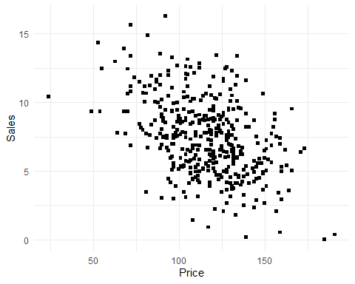

#Plotting the sales against the price using ggplot

#It can be found from the plot that #x and y that is price and sales variables of carseats dataset have negative or inverse relationship #There is a linear relationship between two variables x and y #It can also be seen that the points are scattered and are not too close which indicates that the relationship between the variables is not too strong.

cor(Carseats$Price, Carseats$Sales)

## [1] -0.4449507

#Printing out the correlation of two attributes price and sales #The calculated correlation value of two attributes price and sales is -0.4449507 which suggests that the two attributes are negatively correlated.